Kobbefjord Access Application Form
Any research project planning to implement a scientific activity at the Kobbefjord Site (NERO - Nuuk) must submit a completed copy of this application form no later than 2 months before the beginning of fieldwork. The form should be e-mailed to Josephine Nymand (jony@natur.gl)
The application must be filled in using a computer or filled in by hand using capital letters throughout.
When signing this form as a principal investigator (PI) you acknowledge and accept the conditions and terms in the Kobbefjord Site Manual as well as the responsibility to inform all your co-workers of the content of the manual.
We kindly inform you that staying at the field site in Kobbefjord is at your own risk. All project participants (including PI) should be properly insured during their stay in Kobbefjord/Nuuk (e.g. have relevant injury and medical insurance) either by insurances issued by a commercial insurance company or by self-insurance by their institution. Neither the Greenland Institute of Natural Resources (GINR) nor Asiaq - Greenland Survey will take any responsibility for the safety of external users of the field station in Kobbefjord.
1. Project title

2. Affiliation with network (e.g. DEFROST, INTERACT)

3. Principal investigator (PI)

4. Institution of PI
Institution:
Address:
Phone:
E-mail:
Institutional VAT/CVR-number:

5. Specify all participants in the fieldwork in Kobbefjord (including the PI, if participating)
Participant no. 1
Name:
Date of birth (DDMMYY):
Institutional address:
E-mail:
Phone (institute):
Nationality:
Proposed field work period (start and end dates):
Previous experience with working in Greenland/Arctic areas: YES NO
Contact person (in case of emergency):
Phone:
E-mail:

Participant no. 2
Name:
Date of birth (DDMMYY):
Institutional address:
E-mail:
Phone (institute):
Nationality:
Proposed field work period (start and end dates):
Previous experience with working in Greenland/Arctic areas: YES NO
Contact person (in case of emergency):
Phone:
E-mail:

Participant no. 3
Name:
Date of birth (DDMMYY):
Institutional address:
E-mail:
Phone (institute):
Nationality:
Proposed field work period (start and end dates):
Previous experience with working in Greenland/Arctic areas: YES NO
Contact person (in case of emergency):
Phone:
E-mail:

Participant no. 4
Name:
Date of birth (DDMMYY):
Institutional address:
E-mail:
Phone (institute):
Nationality:
Proposed field work period (start and end dates):
Previous experience with working in Greenland/Arctic areas: YES NO
Contact person (in case of emergency):
Phone:
E-mail:

Participant no. 5
Name:
Date of birth (DDMMYY):
Institutional address:
E-mail:
Phone (institute):
Nationality:
Proposed field work period (start and end dates):
Previous experience with working in Greenland/Arctic areas: YES NO
Contact person (in case of emergency):
Phone:
E-mail:
Participant no. 6
Name:
Date of birth (DDMMYY):
Institutional address:
E-mail:
Phone (institute):
Nationality:
Proposed field work period (start and end dates):
Previous experience with working in Greenland/Arctic areas: YES NO
Contact person (in case of emergency):
Phone:
E-mail:

6. Health problems
All fieldwork at the Kobbefjord Field Site is at your own risk. GINR or Asiaq will not take any responsibility for problems caused by any health problems you may have. We encourage you to tell your colleagues and fellow fieldworkers if you have any known chronic diseases that require medical treatment (e.g. diabetes and heart problems) and if you have any known allergies.
7. Project objectives and abstract of activities for the field work (max. 1500 characters at font size 10)

8. Area of activity. Please indicate on map where your field work will take place
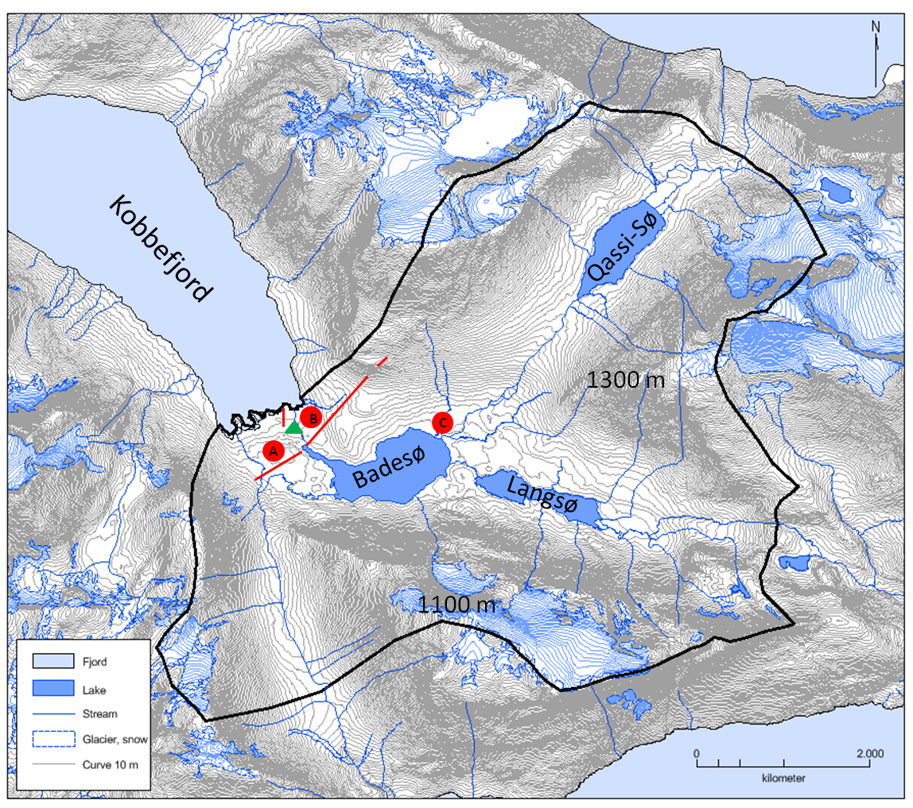

A

The red dots and lines mark areas where access is limited and regulated:
- The fen site
- The C-flux site
- The heath site.
See the “Kobbefjord Site Manual” regarding restrictions. The red lines mark the NERO line (vegetation transect). The green triangle marks the location of the cabin and generator hut.
Please note that placement of permanent equipment and location of your plots etc. must be approved by GINR and Asiaq.

9. Description of any planned habitat or species "manipulations" or "destructions", i.e. the degree of invasiveness (will you be sampling or removing anything?). Please note that any manipulations or destructions must be approved by GINR and Asiaq.
Field work includes removal of: SOIL FLORA/FAUNA WATER
Description of the amount, size of affected area, GPS-position(s) etc.:

10. Description of any planned additions to the system in Kobbefjord. Please note that any additions must be approved by GINR and Asiaq.
Field work includes adding of: SOIL FLORA/FAUNA WATER
NUTRIENTS INFRASTRUCTURES/EQUIPEMENT
Description of the amount, size of affected area, GPS-position(s) etc.:

Duration of additions:
SHORT TERM (within one season) Date of removal:
LONG TERM (more than one season) Date of removal:
PERMANENT

11. Additional information including information on how the manipulated areas are to be restored again. This must include information on when and how the restoration will take place and who is responsible for the restoration.

12. Post field work information to be sent to jony@natur.gl
A report on the field work must be submitted to Josephine Nymand, jony@natur.gl. The report must include a description of what was done, and any relevant information (including GPS-positions) relating to the project. The report is to be used for the Annual NERO Report (please see examples in the latest report http://www.nuuk-basic.dk/publications/annual-reports/ in the section "Research Projects"). Please use the following formatting:

The contribution must comprise a title, name of author(s), affiliations of the author(s), text, figure(s), table(s), figure and table legends and references. The text must be in Microsoft Word format and be no longer than 3000 characters (not including author(s) and affiliation of authors), and with a maximum of three tables/figures/photos. Please use as little formatting as possible. Tables must be sent as Microsoft Excel files. Figures/graphs must be in Excel or EPS formats. Please send the figures/graphs in colour. If maps are needed they must be sent as EPS files in colour and including an arrowhead that points to the north, a scale bar and at least one coordinate. Photos must be sent as PSD files (Photoshop files), TIF files or JPEG files. Please send the photos in colour and remember that EPS files must be vector based.

Before leaving Nuuk please fill in Appendix A and send or hand over to Josephine Nymand, jony@natur.gl

Further, a copy of any publications (reports, peer-reviewed papers etc.) following the field work must be sent to jony@natur.gl

Appendix A - Registration of plots, harvest and manipulations
Project name

Permit number (see project approval)
Project holder (name of responsible person)
Project holder email

Plot ID
(name of plot)
Location (WGS84,  UTM zone 22W) | UTM_N:  UTM_E:  Use next page or digital file if there is more than one position
Type | □ Permanent non-invasive plot  □ Permanent infrastructure/equipment  □ Harvest (collection of whole or parts of organisms, soil samples etc)  □ Manipulation  □ Other (specify):
Manipulation | □ None  □ Type (specify):
Target 1 | □ Soil  □ Vegetation  □ Arthropods  □ Other (specify):
Target 2 | Please specify exactly what is sampled
Start date
(YYYY-MM-DD)
End date
(YYYY-MM-DD)
Total number of samples in plot
Appendix A - Registration of plots, harvest and manipulations, continued
Plot ID  (name of plot) | UTM_N | UTM_E | Total number of samples in plot | Remarks

